Dana 60 Axle Set
Installation Instructions

- Remove the vehicle’s front axles per the manufacturer’s recommended procedures. Make sure to keep all hardware that is removed until assembly is completed, as some of the hardware may need to be reused.

- With the stock front axles removed, install the orange boot to see what, if anything, needs to be modified. The most common modification that needs to be preformed is the area where the brake caliper mounts to the knuckle.

- After any and all modifications are preformed, our axle shafts can be assembled, minus the orange boot, in a bench vice, using a flat head screw driver and a hammer. Using the flat head screw driver, the snap rings may need to be compressed, like the photos on the next page illustrate. The hammer may be needed to lightly tap the shafts, while compressing the snap rings, to get the snap rings and shafts fully seated into the CV joint.
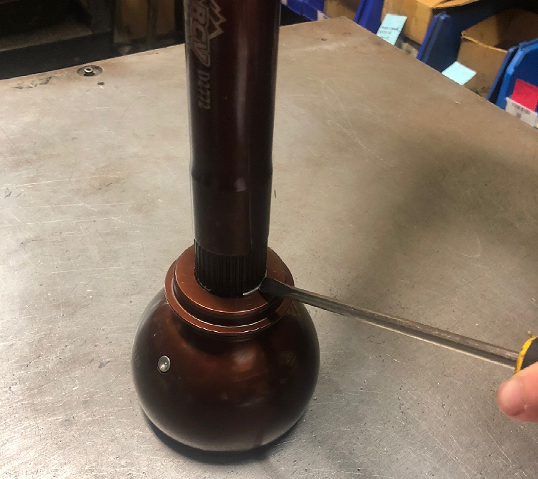

- Once the axle assembly is ready to slide into the housing, place the orange boot in between the axle housing and the knuckle. Slide the axle assembly into the hole in the boot and into the differential.

- Before seating the shaft all the way into the differential carrier, it is now time to install the orange boot over the CV joint using the supplied boot installation/removal tool. The best and easiest way to achieve this is by placing the boot install/removal tool, between the orange boot and the axle housing. Once that boot tool is installed, place a zip tie between the CV joint and the boot. What this zip tie does is allow the air to escape while the boot is being installed. Once the boot is seated, remove the zip tie and the boot tool.

- Once the boot is fully seated, finish sliding the axle assembly into the differential carrier. Make sure the shafts are fully inserted into the carrier. To make sure the shaft is fully inserted into the carrier, try to spin the axle shaft. There should be some resistance while trying to turn the axle, if the axle is fully inserted into the carrier.
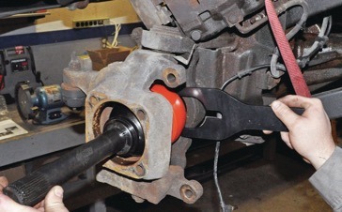

- Now that the axle assembly is fully seated in the carrier, assemble the remainder of the front axle per the manufacturer’s instructions and torque specifications.

For installation videos, or other technical articles regarding this product please visit: www.rcvperformance.com/tech-info

